Basic temperature analysis was done using a MATLAB App ‘*IoT Data Explorer*’. This app provides the ability to compare data from one time to another. The ThingSpeak Channel consists of two fields monitoring temperature that is located inside building.

In the below image, 28 Dec 2020 is used as a start date and compared with one week prior for both locations.

The blue line is the indicated date, and the orange is for the week before. Temperature changes throughout a 24hr cycle on the ground floor were closely correlated. Overall, the recent temp data is lower across the day when compared with a week prior. However, the First-floor minimum temperature never drops below 18 °C for the given dates, this is would be expected as heat rises it would sustain a higher temperature for longer. It would also lag behind the ground floor when the temperature begins to drop.

From the data below the increase in temperature during the evenings can be explained by the use of central heating. It then begins to drop after 12pm when everyone is sleeping.

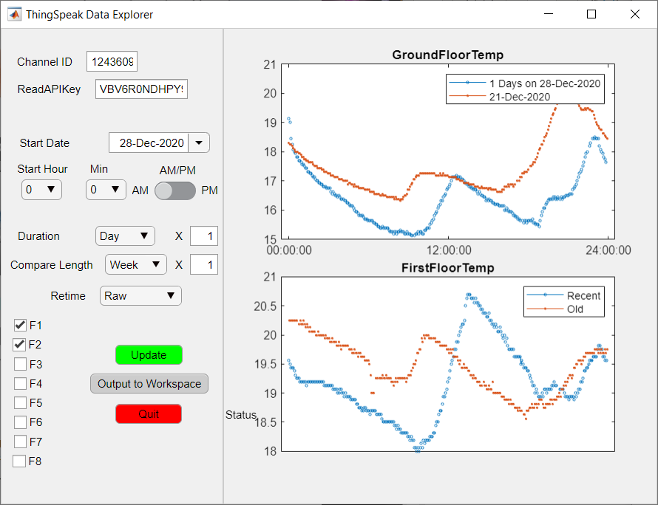

Figure 1: 24hrs of temperature data one week apart

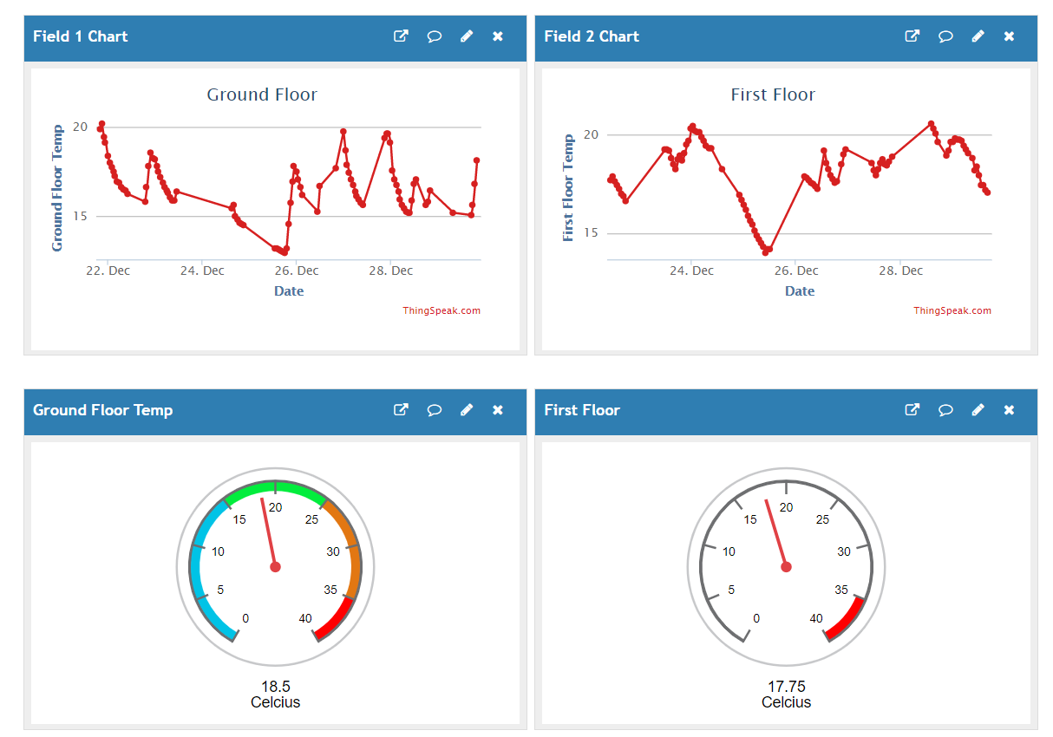

Figure 2 ThingSpeak Raw Data

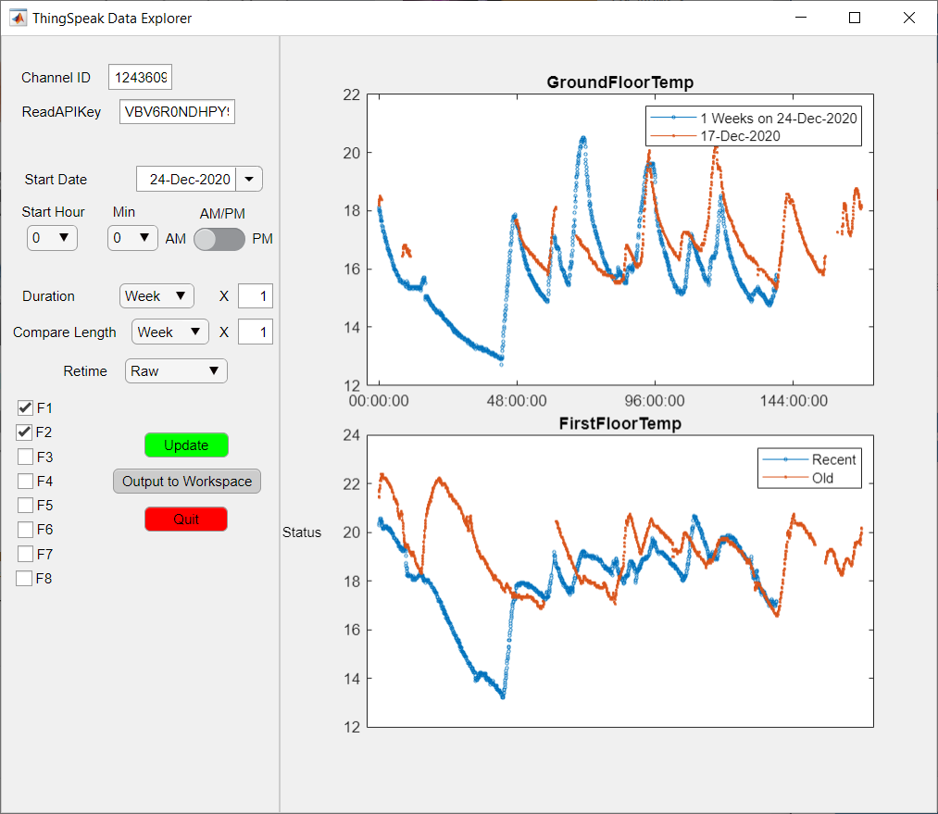

Figure Comparison of Seven days of temperature data one week apart